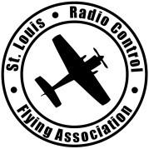
FIELD RULES
St. Louis Radio Control Flying Association
March 2024

- Only members and guests of the Saint Louis Radio Control Flying Association with current Academy of Model Aeronautics (AMA) membership cards are permitted to fly at this site. SLRCFA members are required to have their membership cards on their person and visible while at the field.

- The Official AMA rules and regulation shall be applicable to all flying activities at this field. In situations where specific guidance is not provided, sound judgment and common sense shall prevail.

- Per FAA requirements, ALL aircraft should have their FAA sUAS number visible. (can be inside of the aircraft if accessible without the use of tools)

- Only narrow banded Radio Control systems are permitted to operate at this flying site and all pilots will have completed a successful radio equipment ground check before the first flight of a new or repaired model. (It is suggested that each day prior to flying, ground checks are conducted and that prior to each flight transmitter/receiver function be verified.) SLRCFA is a 2.4GHz preferred flying site. All other frequencies of operation (72MHz, 27MHz, 50 and 54 MHz) may be used at the pilot’s own risk. However, the use of a frequency pin to identify the frequency in use is highly recommended. Pins, often clothespins, can be marked with the color or channel number of the frequencies they represent and should be placed on the provided flight-line control board when in use.
- No more than six aircraft are allowed to fly at one time in the primary flying area.

- Piston and turbine engines are not permitted to run before 9:30AM or after 10:00PM.
- All piston engines are required to have a muffler. All engines except turbines shall not exceed a sound limit level of 96 decibels (measured from 25 feet perpendicular to the aircraft on a solid surface). Propeller driven aircraft should not “rip the prop.”

- Pilots shall not fly new or rebuilt model aircraft until the aircraft has been inspected and approved by two other club members.
- No fueling or starting engines from under the pavilion or in front of the pavilion. ALL planes must be started from the flight stands or using personal hold downs. Personal hold-downs and flight stands must be located by one of the two starting pads in the startup zones. Electric Airplanes should not be armed until they are beyond the white taxi lines are located in the startup zone. See Diagram (Startup Zone).

- Takeoffs and Landings are permitted on paved or grass runways only. Taxing out to the runways is permitted, provided it is past the white lines at either end of the runway.

- No Spinning props past double white line at pilots’ station in center of runway.
- Primary flying area pilots must stand in the designated Pilot Zone located at the center of the runway. Exception can be made if pilot chooses to stand away from center station to one of the old (bush) stations as long as all flying pilots agree (takeoff in pattern) and loud communication is made for all pilots to hear.
- Pilots in the pilot zone should stand as close as practical to the other pilots already flying. Pilots may fly outside of the Pilot Zone only if they are flying an aircraft deemed to have a pilot-challenging take-off or landing characteristics and have established clear verbal communication with ALL pilots in the air and receives their acceptance and awareness of the challenging aircraft. All Pilots are encouraged to utilize a spotter.

- FPV pilots are encouraged to always utilize a spotter.
- The first pilot to begin flying must establish a “left to right” or “right to left” takeoff and landing pattern. All subsequent pilots must follow the established pattern. Use clear verbal communication to identify the pattern if you are unsure. The pattern may only be changed during flight by an agreement among ALL pilots currently in the air using clear verbal communication.

- Positively no flying over the pilot side of the runway, pit area, spectators, or parking area. (Depicted as a black line. Marked by 2 Orange cones nearest to the pilot’s stations at the property line) Landing out of the pattern is permitted only in cases of emergency. 3D maneuvers over the runway are only allowed when all other pilots in the air agree to the practice, established by clear verbal communication.

- Low altitude, high speed passes are only permitted beyond an imaginary line represented by the outer edge of the asphalt runway.
- Loudly and clearly announce your intentions with your plane of taxiing (coming out), taking off, and landing. Also announce your intentions when you need to cross the runway to retrieve an aircraft. ALL pilots flying must acknowledge your callouts before proceeding with your intentions. Additional guidance is provided in our Pilot Communication document.

- All Helicopters and Multirotor (Rotorcraft) must be carried to and from the runway or rotorcraft zone. All hovering shall be conducted in a designated rotorcraft zone and forward pattern flight is not permitted from the hovering area. Rotorcraft forward pattern flight is permitted from the Primary flight line.

- Pets may accompany SLRCFA members in accordance with St. Louis County Ordinances. (Leashed) ALL pets are the sole responsibility and liability of the pet’s owner. Owners of unruly/dangerous pets, or pets exhibiting behavior that is potentially damaging to aircraft or facilities are required to remove the pet from the field.

- Night Flying is permitted in accordance with AMA rules. Whenever the field flood lights are illuminated (after sunset or before sunrise) all pilots must fly from the center Night Flying Pilot zone.

- Absolutely no talking on the phone while flying.
- Any SLRCFA Member shall have the authority to enforce the rules herein. In most cases a simple warning will remedy a situation. However, if a pilot deliberately refuses to comply with a specific rule any SLRCFA member may file a grievance following the procedures listed in SLRCFA’s Operating Procedures.

- Repeated failure to comply with these rules and regulations by any member may result in termination of their membership in the Saint Louis Radio Control Flying Association pending a hearing by the Board of Directors of this Association. The process begins with a letter issued to the offender, member signs and returns the letter. The second infraction mandatory suspension or expulsion from SLRCFA to be determined by the SLRCFA Board of Directors.

- These Rules and Components of these rules may be suspended or amended by AMA-Designated Contest Directors (CD) during AMA sanctioned events. For non-sanctioned events, these rules or components of these rules may only be suspended for the duration of the event by an approved SLRCFA Board Motion or by a SLRCFA Board designated (non-AMA-designated) Contest Director.
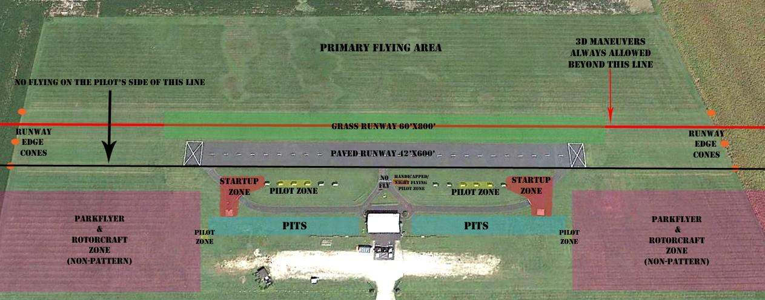
SLRCFA FIELD DIAGRAMS TO AID RULE INTERPRETATION
